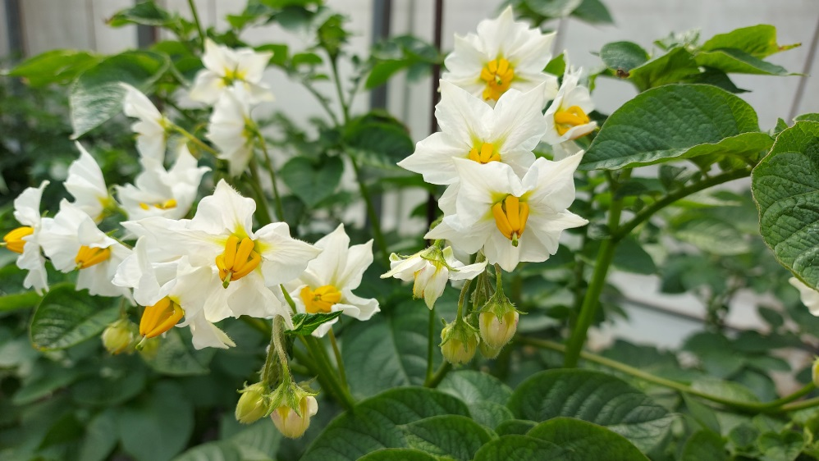
(Feel free to change the photo of the crop)

Questionnaire
How to improve the supply of organic seeds

- Attitudes towards organic seed (OS) in your county. Rank the five-point scale for each statement (1 – strongly disagree; 2 – disagree; 3 – neutral; 4 – agree; 5 – strongly agree)
OS is easily available for varieties that I want to use | 1 | 2 | 3 | 4 | 5
Price for OS is accessible | 1 | 2 | 3 | 4 | 5
Availability of OS has improved in the last 5 years | 1 | 2 | 3 | 4 | 5
The quality of OS that I use is high | 1 | 2 | 3 | 4 | 5
I’m encouraged to use OS by my certifier | 1 | 2 | 3 | 4 | 5
By using OS, I support the competitiveness of the organic sector | 1 | 2 | 3 | 4 | 5

- Ranking of different actions to boost the use of organic seed (OS) in your country. Rank the five-point scale for each statement (1 – most important; 2 – important; 3 – average importance; 4 – not important; 5 – least important)
Improve availability of OS for locally adapted varieties | 1 | 2 | 3 | 4 | 5
More efforts in breeding for organic farming | 1 | 2 | 3 | 4 | 5
Using open pollinated varieties | 1 | 2 | 3 | 4 | 5
More information on availability of OS in foreign markets | 1 | 2 | 3 | 4 | 5
Stricter national rules for grading | 1 | 2 | 3 | 4 | 5

- Technical challenges in organic seed production. Rank the five-point scale for each statement (1 – most important; 2 – important; 3 – average importance; 4 – not important; 5 – least important)
Yield losses/volatility | 1 | 2 | 3 | 4 | 5
Seed borne pests and diseases | 1 | 2 | 3 | 4 | 5
Weed contamination | 1 | 2 | 3 | 4 | 5
Finding organic seed multipliers | 1 | 2 | 3 | 4 | 5
Seed storage and treatment | 1 | 2 | 3 | 4 | 5
Germination rate and seed size | 1 | 2 | 3 | 4 | 5
Hybrid propagation | 1 | 2 | 3 | 4 | 5

- Marketing issues with organic seed (OS). Rank the five-points scale for each statement (1 – strongly disagree; 2 – disagree; 3 – neutral; 4 – agree; 5 – strongly agree)
OS production is more costly than conventional seed production | 1 | 2 | 3 | 4 | 5
OS is an important part of organic agriculture | 1 | 2 | 3 | 4 | 5
The OS market might become profitable in the next 5 years | 1 | 2 | 3 | 4 | 5
Demand for OS is more volatile than demand for conventional seed | 1 | 2 | 3 | 4 | 5
Farmers are willing to pay the higher price for OS | 1 | 2 | 3 | 4 | 5
Offering both organically & conventionally produced seed is logistically too costly | 1 | 2 | 3 | 4 | 5

- Policy measures to enhance organic seed (OS) production. Rank the five-point scale for each statement (1 – strongly disagree; 2 – disagree; 3 – neutral; 4 – agree; 5 – strongly agree)
More research on organic seed production economics | 1 | 2 | 3 | 4 | 5
Phasing out derogations in the new organics regulation | 1 | 2 | 3 | 4 | 5
Stricter derogation rules in the next 5 years | 1 | 2 | 3 | 4 | 5
More information on organic seed market demand | 1 | 2 | 3 | 4 | 5
Expand the range of organically allowed seed treatments | 1 | 2 | 3 | 4 | 5
Introduction of subsidies to support organic seed production | 1 | 2 | 3 | 4 | 5
Increase training on organic seed production | 1 | 2 | 3 | 4 | 5

- Organic seeds availability. Rank the five-point scale for each crop (1 – enough in the market; 2 – occasionally available; 3 – not available; 4 – depending on the variety; 5 – I use home saved seeds). Multiple choices possible.
Wheat | 1 | 2 | 3 | 4 | 5
Soybean | 1 | 2 | 3 | 4 | 5
Potatoes | 1 | 2 | 3 | 4 | 5
Buckwheat | 1 | 2 | 3 | 4 | 5
Corn | 1 | 2 | 3 | 4 | 5
Vegetables | 1 | 2 | 3 | 4 | 5
Small grains | 1 | 2 | 3 | 4 | 5
Grain legumes | 1 | 2 | 3 | 4 | 5
Oilseeds | 1 | 2 | 3 | 4 | 5
Fodder plants | 1 | 2 | 3 | 4 | 5

- What are important traits for an organic variety in your region? Rank the five-point scale for each statement (1 – most important; 2 – important; 3 – average importance; 4 – not important; 5 – least important)
Yield | 1 | 2 | 3 | 4 | 5
Yield stability | 1 | 2 | 3 | 4 | 5
Weed suppression | 1 | 2 | 3 | 4 | 5
Quality (e.g. baking quality) | 1 | 2 | 3 | 4 | 5
Lodging | 1 | 2 | 3 | 4 | 5
Maturity | 1 | 2 | 3 | 4 | 5
Taste | 1 | 2 | 3 | 4 | 5
Diseases resistance (please give examples):  ____________________________________  ____________________________________  ____________________________________  ____________________________________ | 1 | 2 | 3 | 4 | 5

- Rank the five-point scale for your willingness to grow composite cross populations (CCP) on your farm (1 – strongly disagree; 2 – disagree; 3 – neutral; 4 – agree; 5 – strongly agree)
CCP (write down the crop(s) you are interested in):  ____________________________________  ____________________________________ | 1 | 2 | 3 | 4 | 5

I would like to receive news about the ECOBREED project and the results of the survey by e-mail:
__________________________________________________________________

Questionnaire completed by (mark)
- Farmer
- Seed industry
- Extension service
- Research/Education
- Policy maker
- NGO
- Other

Additional questions or comments:
__________________________________________________________________
__________________________________________________________________
__________________________________________________________________
__________________________________________________________________
__________________________________________________________________
__________________________________________________________________

